# CHAPTER-1

## 1. INRODUCTION

## 1.1 INTRODUCTION OF PROJECT

Online airlines Ticket Booking System is a web application whose main aim is to provide ease and secure online booking facilities to the customers via digitalized systems. It is one of the user-oriented web-application in which user can login to the system by registering their personal details so that they can check available flights, available seats and date time and ticket booking etc as per their destination. People do not want to spend their valuable time and efforts by standing in a queue to book a ticket. So, my web-application helps them to book ticket to their destination from anywhere at anytime 24/7 hrs within a click away. Customers can book a ticket from anywhere at any time via internet connection.

## 1.2 BACKGROUND OF SYSTEM

Online Airlines Ticket Booking System is web portal where people can book their tickets from their home which is accessible 24/7. They can book tickets for specific date and choose timing for their required destinations. First of all, they need to register in the app and login to browser so that they will be notify about available seats, available flights in online airlines booking system. There will be ease in cancellation of tickets for customers also.

Online Airlines Ticket Booking Management System is fully customized which is accessible via internet connection only. It is user-friendly application. The main aim of my project is to provide more ease, user satisfaction and to save customer time and efforts while booking flight tickets. In my project, I have used core PHP for programming and Laragon for managing database of airlines.

## 1.3 OVERVIEW OF PROJECT

My project is about Online Airlines Ticket Booking Management System. It is a web portal where people can book their seats and tickets 24/7 anywhere anytime. It facilitates people in many ways like booking tickets from their home without standing in a long queue.

## 1.4 AIMS AND OBJECTIVES

The main aim of my project is to provide quality services to the people while buying online airlines ticket 24/7 anytime anywhere. It also helps reduce human resources and promote ticketing system in internet also. It helps to provide detailed information about airlines ticket to the system.

The main objectives of online ticket booking system is to be able to solve the issues in the existing system regarding to the accuracy, usability, efficiency, effectiveness, speed and user-friendliness. It manages all the information related to flights, departure time, ticket price etc. Its main objective is to reduce human resources and focus more on customer satisfaction also. It will increase profit for particular organization also. People can also save on travel agent fees by purchasing online tickets, instead of contacting a travel agent.

# CHAPTER-2

# 2. ANALYSIS

## 2.1 Introduction to Analysis

Analysis means the method of examining and evaluating data or information in a methodical way by breaking problems or particular topic into smaller parts in order to get better understanding of it. The term analysis has been introduced in the study of mathematics and logic since before Aristotle (384-322 B.C). It is the process of figuring out the basic elements of a project and deciding how to merge them in the best way to solve the problems. The main objective of doing analysis is to determine the strength and weakness of relevant topic by making best out of waste. It is the process of applying statistical practices to organize, represent, evaluate and interpret data. Analysis must be done before giving implementation to any project in order to know the strength and weakness of that topic so that overall quality of a system can be easily customized and improved and occurring mistakes can finally reduced.

**Need of analysis**

Before conducting analysis, we mostly clearly understand for whom and for what purpose we are going to conduct analysis. We need to perform analysis because it helps us to calculate prototype and interrelationships in the data and demonstrate the results. It also empowers us to answer questions and make important decisions using more than a visual analysis. The main objectives of performing analysis is to understand the requirement first and then to formalize it. The main need of doing analysis is to identify areas for improvement and make any enhancements if necessary. To get the better output and decision, analysis is performed. There are different type of analysis like PEST, SWOT and CATWOE analysis.

**PEST, SWOT, CATWOE Analysis**

**PEST (Political, Economic, Socio-cultural and Technological**) analysis is an easy, commonly and broadly used method that helps us to explore the political, economic, socio-cultural and technological changes in our business environment. Other type of issues like legal and environmental can also be assessed using PEST analysis. It helps us to understand strategic development, build up a competitive analysis and markets, knowledge management and so on. PEST analysis is mostly used in larger organization where we can identify more complex problems and issues.

**SWOT (Strength, Weakness, Opportunity and Threats)** analysis is an intentional planning method which is used for collecting, structuring, presenting and reviewing data that particularize the aims of an organization and point out the strength, weakness, opportunities and threats that are apposite to achieving the aims. It helps to focus in the areas of strength and where the greatest opportunities lies and list out the dangers in the form of weaknesses and threats which are both internal and external.

**CATWOE (Customer/Client, Actor/Agent, Transformation, World view, Owner and Environment)** analysis helps in defining a root definition of any project and also the part of Soft System Methodology also. It helps to identify, analyze and categories all the participants, processes and factors involved in the system. In CATWOE analysis, the needs of the users need to be taken into account in order to improve productivity and quality assertion. The term CATWOE refers to:-

* **Customer/Client**: - Customer/Client is the stakeholders those who are directly take advantage or not from the work of an organization. They also suffer when there is sudden change in the system. They are the real beneficiaries of the renovation.
* **Actor/Agent**: - Actor or agents are directly involved to the performance of the system. They are more responsible for making the transformational activities. These stakeholders are directly involved for solving the problems and issues, searching new ideas and their solutions.
* **Transformation**: - Transformation is the third step of CATWOE analysis where analyst needs to consider input, output and process of the system that is responsible for change that the system or process brings about. Analyst must know about what happens to the data and what processes will be affected by development of the system.
* **World view**: - Worldview is the most crucial step in CATWOE where stakeholders repeatedly have different proceeds to the same issue, with other interest. It is the justification for the transformation of the system or process. It helps to know what is going on in and outside the organization which is affecting development of the system or not and gives the solution form different perspective.
* **Owner**: - Owner is the one who owns the organization and has the power to make changes. Owner is the type of stakeholder who owes authority for the business system. Owner is the admin user of the project who has all the authorities and power to make future planning like when to start or stop the project, make changes to the project or not and decide on whether to go ahead with the change.
* **Environment**: - Environment is the rule and limitations surrounding the business system. As Analyst needs to be aware of the demands of the political, legal, economic, social, demographic, technological, ethical, competitive and environmental factors and their associated restrictions and limitations. So, this part of CATWOE helps to investigate whether this will affect the analysis and development of the system.

By analyzing both type of analysis, I have used CATWOE analysis in my project because this analysis is a system thinking tool of SSM to prepare widespread root definition models. It focuses on the existing system and processes that take place within an organization and requires studying about how the features of elements within the system or process cooperate externally and internally. It collects the views of different stakeholders in a common platform and provides an aggregate understanding that incorporates the different viewpoint.

## 2.2 Feasibility Study

Feasibility study is an assessment of the probable impact of a proposed project. It is one of the most important steps in software development process. It helps to examine and decide whether the particular project is technically, financially, socially, economically and legally feasible or not and also decide whether our project is cost effective or not. The main importance of this study is that it helps project planner to focus on the project and collapse all of the possibilities. To examine whether the factor presented in a project makes a project success or not is the main purpose of this study. We need feasibility study to determine the aims and goals, potentiality, problems and solution of the existing system to determine which solution requires less time and is easy for running from the point of view of customer or employees.

**Types of feasibility study:-**

1. **Economic feasibility: -** A system can be developed more effectively if there is good investment. In my project, I have performed this feasibility study to know the financial transactions and to evaluate the cost of my project whether the financial benefit is equal or exceed the cost. This involves the possibility of the proposed project to generate economic benefits. This analysis is an important aspect of evaluating the economic feasibility of any project.
2. **Technical feasibility: -** The technical capability of the individual as well as the available technology should be considered in technical feasibility. This feasibility accessesthe details of how you will distribute a product or service to the customers (i.e. materials, labour, transportation, business location, technology needed etc). In my project, I have used this feasibility study to know whether the existing system is doing what is suggested or not and if the proposed tools have the technical ability to hold the data required to use the new system.
3. **Schedule feasibility: -** this feasibility study helps us to estimate time duration and examine whether our project can be completed in the exact time or not. This process helps to gain to which time frame and finalization dates for all major activities within a project meet organizational deadlines and restrictions for affecting change. This feasibility study helps my project by evaluating the time required to complete my project and manage the time to complete the project within given time frame.
4. **Operational feasibility: -** This feasibility system is dependent on the human resources available for the project. This measures how well our organization will be able to solve the problems and take advantages during the course of the project. This feasibility study is about how well you solve the problems if system had investigated problems. Proposed project is more beneficial if it meets the organizational operating needs and requirements. Some of the important factors which helps in my project includes:-

* **Is there enough support for the management from the users?**
* **Will there be any conflict from the user that will challenge possible application benefits?**

1. **Legal feasibility: -** It deals with the legal issues for the development of the project which determines whether the proposed system dispute with the legal requirements or not. If our development system is not meeting the government or organizational rules then this process helps to solve those problems. This feasibility study helps my project by considering legal issues and requirements whether it fulfills the government rules and regulations or not.

## 2.3 Requirement Analysis

Requirement analysis is the important aspects of project management which is the process of defining the potential of the user for an application that is to be built or modified and must be quantifiable, relevant and detailed and must determine user expectations for a new or modified product. Requirement analysis is the team effort that requires a combination of hardware, software and human factors as well as ability in dealing with the people. The main objectives of requirement analysis are to reach at a point that details all the requirement of the system, functional as well as non-functional.

**Functional Requirement**

Functional requirement are the product quality. Its function must be designed directly for the users and their benefit. Functional Requirements include:

* Data input into the system
* Procedure performed by the system
* Work flow of the system
* Data output from the system
* Those who can enter the data into the system
* How the system meets the applicable requirements

Functional Requirements describes what the system should perform which involves estimation, technical details, data manipulation and processing and other specific functionality that define what a system is supposed to achieve.

The functional requirements are:-

1. User Register
2. User login
3. Book Flights
4. User Logout
5. Ticket checking
6. Add, update and modify customer details
7. Review order

|  |  |
| --- | --- |
| **Functional Requirements ID** | **Title** |
| F1 | User login |
| F2 | User registration |
| F3 | Book flights |
| F4 | User Logout |
| F5 | Ticket checking |
| F6 | Add, Update and delete customer details |
| F7 | Review order |

**Non-Functional Requirement**

Non-functional requirements describe how the system works and performs certain functions which include physical environments like location of equipments, their interfaces, user and human factors, performance, documentation, resources, security (backup, firewall) and quality commitment.

These requirements are the indirect supporting features in the systems which are:-

* **Reusability**: - Reusability means use of existing resources in some form within the software product development process as these resources are products and by products of the software development life cycle which includes code, software components, test sets, design and documentation.
* **Usability**: - Usability is the process of prioritizing the important functions based on the usage pattern. Frequently used functions should be experiment for usability.
* **Performance**: - Performance is the part of non-functional requirement which includes performance of the application under unpleasant conditions.
* **Security**: - Security means to protect the information and data which is confidential or non-confidential from external and internal security threats. For safety, data should be transferred through secured protocols.
* **Maintainability**: - The system needs to be cost effective to maintain. So, maintainability requirements may cover various levels of documentation, such as system as well as test documentation.
* **Scalability**: - This requirement helps to prove software behavior under both normal and expected to load condition.

|  |  |
| --- | --- |
| **Non- functional requirements (ID)** | **Title** |
| NFR1 | Reusability |
| NFR2 | Usability |
| NFR3 | Performance |
| NFR4 | Security |
| NFR5 | Maintainability |
| NFR6 | Scalability |

**MoSCoW Prioritization**

This prioritization helps to set the goals and make our task more worthy and relevant. This prioritization allows right things to occur rather than less useful ones by determining a condition estimate the criterion value for the task and sort the list based on the basis value.

MoSCoW prioritization, also known as the MoSCoW method or MoSCoW analysis, is a popular prioritization technique for controlling requirements. This technique is repeatedly used to help key stakeholders understand the importance of capabilities in a definite release. The MoSCoW Method is an acronym made up of the four letters. The two Os have been added to make the word MoSCoW readable; they don't have any meaning themselves. The M stands for 'Must haves', S for 'should haves', C for 'could haves' and W for 'won't haves' where

Must have: - It defines a requirement that has to be fulfilled for the final solutions to be suitable. We cannot deliver a rational solution without it.

Should have: - This is a high-priority condition that should be integrated if possible.

Could have: - This is a satisfying or nice to have requirement but the result will still be accepted if the functionality is not included.

Won’t have: - This shows a requirement that stakeholders want to have but have agreed will not be implemented in the existing version of the system.

Functional requirement:-

|  |  |  |
| --- | --- | --- |
| ID | Functional Requirement | Priority |
| FR1 | User login | Must have |
| FR2 | User registration | Must have |
| FR3 | Book flight | Should have |
| FR4 | User logout | Must have |
| FR5 | Ticket checking | Must have |
| FR6 | Add, delete and update | Must have |
| FR7 | Review order | Should have |
| FR8 | Internet | Must have |
| FR9 | Comment | Could have |
| FR10 | Online chat | Won’t have |

Non-functional requirement: -

|  |  |  |
| --- | --- | --- |
| **ID** | **Non-functional requirement** | **Priority** |
| NFR1 | Reusability | Should have |
| NFR2 | Usability | Should have |
| NFR3 | Performance | Should have |
| NFR4 | Security | Must have |
| NFR5 | Maintainability | Should have |
| NFR6 | scalability | Should have |
| NFR7 | Browser support | Must have |

**Software Requirement Specification (SRS)**

SRS (Software Requirement Specification) is the agreement between the development team and the customer. It is the basic document that connects the gap between user requirement and developer perception. It should address functionality, external interfaces, required performance, quality impute and design limitations manipulate on an implementation.

**Software Requirement**

**Programming language**: - PHP with Laravel framework

**Database**: - Laragon

**UI Design**: - html, Ajax, jquery, JavaScript

**Web browser**: - Mozilla, Google chrome

**Software used**: - Laragon

**Hardware requirement**

**Memory: -** 4GB RAM

**Storage: -** 1 GB

**OS**: - Windows 10 64bits

**USE CASE**

A use case is an approach which is used in system analysis to clarify, identify and organize system requirements. It is made up of a set of possible sequences of connections between system and users. It is a list of actions or events steps usually defining the interactions between a role and system to get a goal. It defines the features to be achieved and the purpose of any error that may be faced.

The characteristics of use case are: -

* Establishing functional requirements.
* Creating the goals of system user interactions.
* Recording scenarios from trigger events to eventual targets.
* Authorizing user to access the functionality of another event.

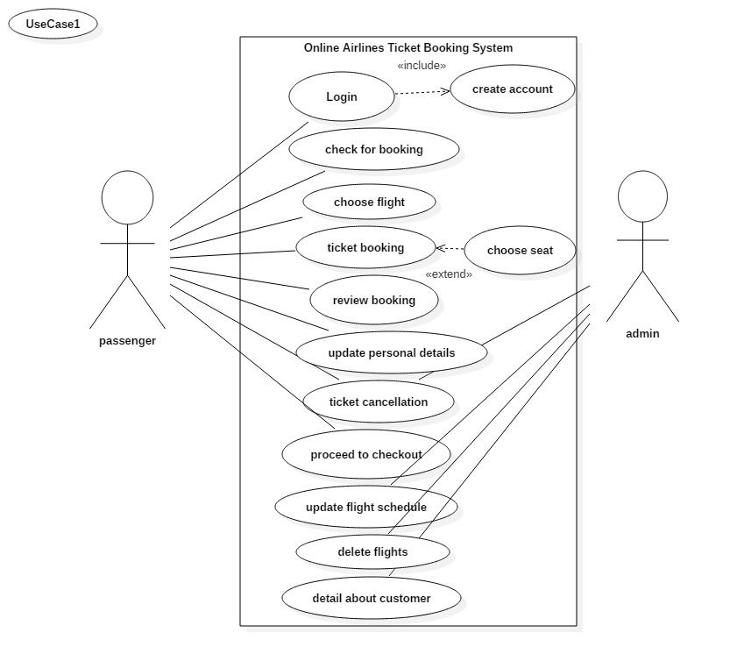

Fig.1:- Use case diagram

|  |  |
| --- | --- |
| Use Case | Description |
| Login | Login is used by passenger in order to authenticate a user. These consist of username and password. |
| Create Account | Account is created by passenger to login, book and check tickets. This the initial stage which is the important part of any system without which we cannot perform other task like login, booking etc. |
| Check for booking | Passenger checks for the availability of the flights. If there is availability of flights then they will do reservation. |
| Choose flights | This task is performed by passenger where they choose appropriate and suitable flights. If it has flexibility in their schedule then they will choose flight and book tickets. |
| Ticket booking | After searching for the suitable flight and ticket, passenger will book ticket. After measuring airlines and travel sites for cheap flight, passenger will book ticket for their destination. |
| Review booking | Review order is done by both passenger and airline agency in order to see whether it can be improved or corrected. This task is done to provide their option. |
| Update personal details | Users are allowed to update their personal details after inserting personal information. |
| Ticket cancellation | Cancellation of ticket is done by both passenger and admin during some circumstances. If there is any problem with the system or if passenger faced any problem then cancellation of ticket is done. |
| Proceed to checkout | After reviewing the flights and cost of ticket, passenger needs to be proceeding to checkout. |
| Update flight schedule | Flight schedule is updated by admin. Admin will update flight schedule in case of flight delayed and changes, changes in weather. |
| Delete flights | Admin can delete the flights if It is not currently available or because of some issue. |
| Detail about customer | Admin will keep detail about passenger through PNR (passenger name record) which is recorded in the computer reservation system. There is personal information about the passenger. |

**Initial Class Diagram**

**NLA**

|  |  |
| --- | --- |
| **NOUN** | **VERB** |
| Flight, name, code, destinations, timing, frequency, users, airports, seats, status, reservations, passengers, price, book, ticket, payment, mail, room, food, schedule, order, flight | Add, update, delete, modify, booking, detail, presenting, filling, cancellation, using, login, register, entering, providing, details, successful booking, visible, download |

**Candidate class (noun):** passenger, order, scheduledflight, travel agency

**Candidate class (verb**): login, register, add, update and delete, booking, details, and cancellation.

## 

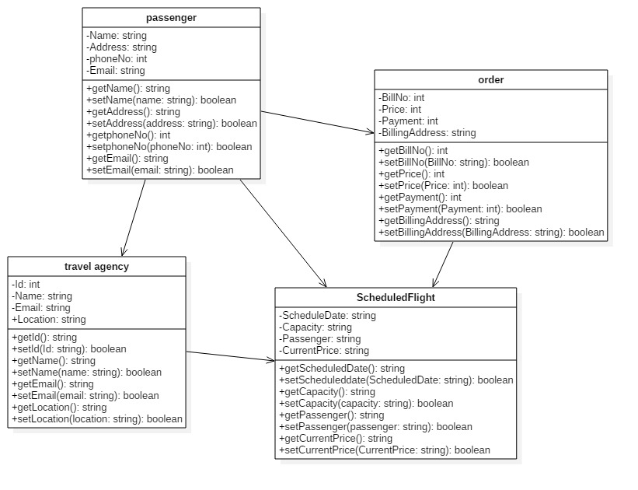

Fig.2:- initial class diagram

## Conclusion

As I have completed my analysis part by discussing SWOT, PEST and CATWOE analysis and also doing feasibility study. Among them, I have chosen to apply CATWOE analysis in my project as it helps to gathers the perceptions of different stakeholders in a common platform and provides a complete understanding that incorporates the different views or perspectives. I have performed feasibility study in order to know whether the project is technically, financially, socially, economically and legally feasible or not. I have figure out the functional and non functional requirements also. In my project, I have included use case diagram and class diagram by doing NLA.

## References

W. Kenton (2004), feasibility study, U.S, Investopedia

S. William (25th October, 2018), requirements blog, Stockholm Sweden, ReQtest

R. Robert (20015), difference between functional and non-functional, New Zealand, Guru99

# CHAPTER-3

## DESIGN

**3.1 STRUCTURAL DESIGN**

1. **CLASS DIAGRAM**

A class diagram is a part of a unified modelling language (UML) that defines and provides the outline and structure of a system in terms of classes, attributes, methods and the relationship between different classes. Class Diagram is functional in all forms of object-oriented programming (OOP). It is a explanation of a group of objects all with similar roles in the system which consists of structural and behavioural features.

The importance of class diagram is:-

1. Display the stable structure of classifiers in a system.
2. Diagram provides basic notation for other structure diagrams authorized by UML
3. Supportive for developers and other team members too.
4. Business analysts can use this system from business outlook.
5. Class diagrams is widely used at the time of construction which can be directly mapped with object-oriented languages
6. It describes the attributes and operations of a class and also manipulates imposed in the system.

Notation used:-

A class notation consists of three parts:-

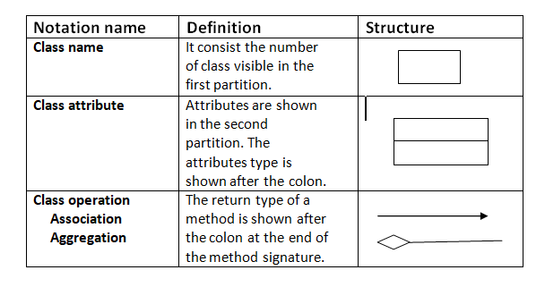

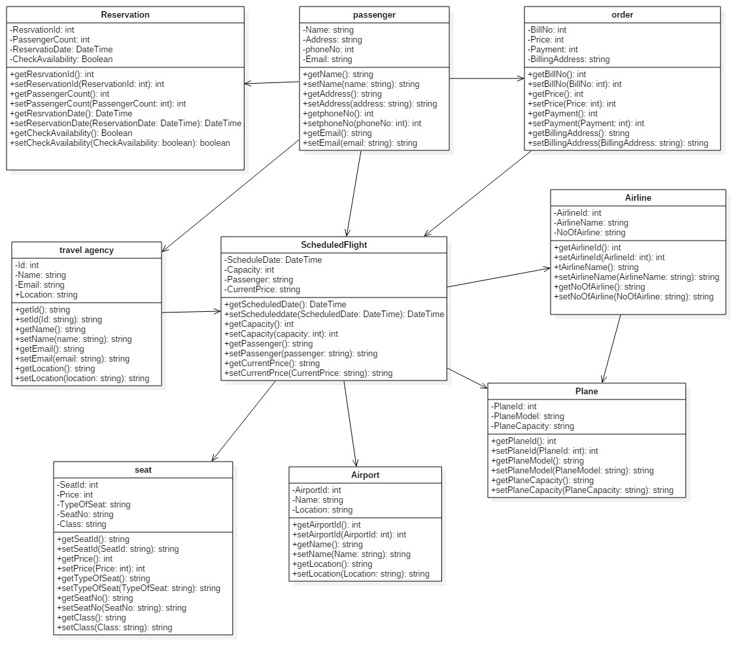

**Fig.: - Class Diagram**

I have attached the class diagram in the design phase of my project because it shows the constant structure of classifiers in a system. It is directly mapped with object-oriented languages and widely used at the time of construction. It helps to model the steady view of an application. It helps to describe the structure of a system by displaying the system’s classes, their attributes, operations and the relationship among objects.

1. **FLOWCHART**

Flowchart is the diagram that represents the workflow or process and series of variation or actions of people or things involved in a complex system or activity. It is a graphical representation of a computer program in relation to its chain of functions. It also be defined as a diagrammatic representation of an algorithm, a step-by-step proceed towards solving task. The flowchart shows the steps as boxes of various kinds and their order by joining the boxes with arrows.

The importance of flowchart is: -

1. It is used in designing and reporting simple processes or programs.
2. It helps to conceptualize what is going on and thereby help understand a process.
3. It helps to find less recognizable features within the process like imperfections and bottlenecks.
4. It is often used in training to document an existing process
5. It evaluates the efficiency of that existing process.
6. It is shown through images how a process is performed from start to finish usually in sequential order.
7. They are better way of communicating the logic of a system.

Figure for used notation: -

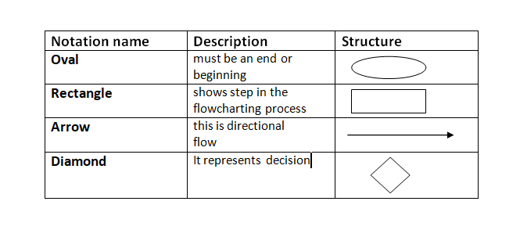

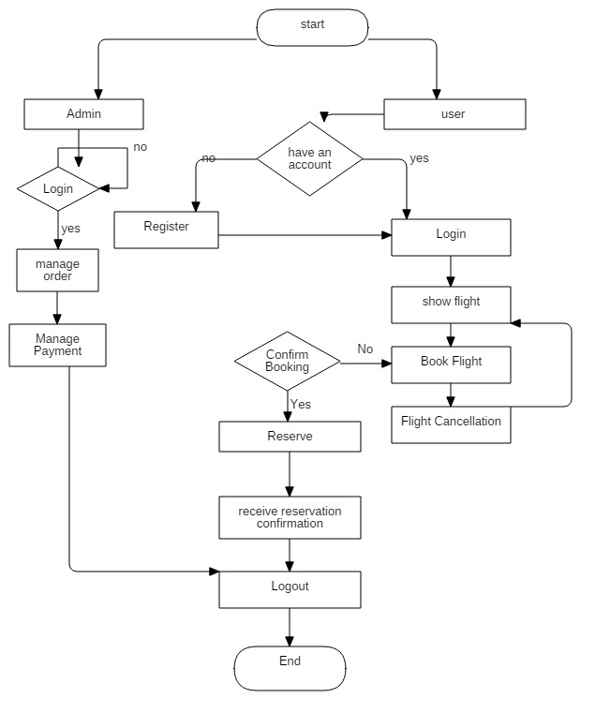

**Fig.: - Flowchart for online airline management system**

I have included the flowchart diagram for designing and documenting simple process and program in my project. It helps to find out the flaws and errors. It is performed in sequential order which helps to understand the process and features. It is the better way of communicating as well as effective ways of analysis because with the help of flowchart, problem can be analyzed in more effective way which reduces cost and wastage of time also.

**3.2 BEHAVIORAL DESIGN**

1. **ACTIVITY DIAGRAM**

Activity diagram is the important diagram in UML which describe the dynamic aspects and graphical representation of workflows of stepwise activities and actions in the system with support for choice, iteration and collaboration. It is basically a flowchart to shows the flow of data from one activity to another activity, control flow from one operation to another and also described as an operation of the system.

Importance of activity diagram:-

1. It is used by programmers as it is advanced edition of flowchart to show workflows.
2. It is used by developers to understand the flow of programs on a high level.
3. It also allows them to figure out impulsion and conditions that cause particular events.
4. It is used to show message flow from one activity to another.
5. It stores the dynamic behavior of the system.

Figure for notation used:-

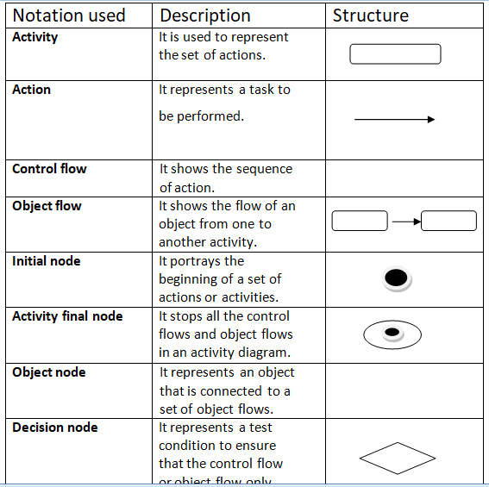

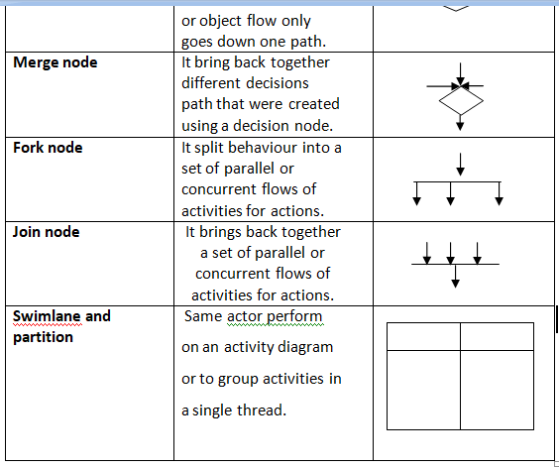

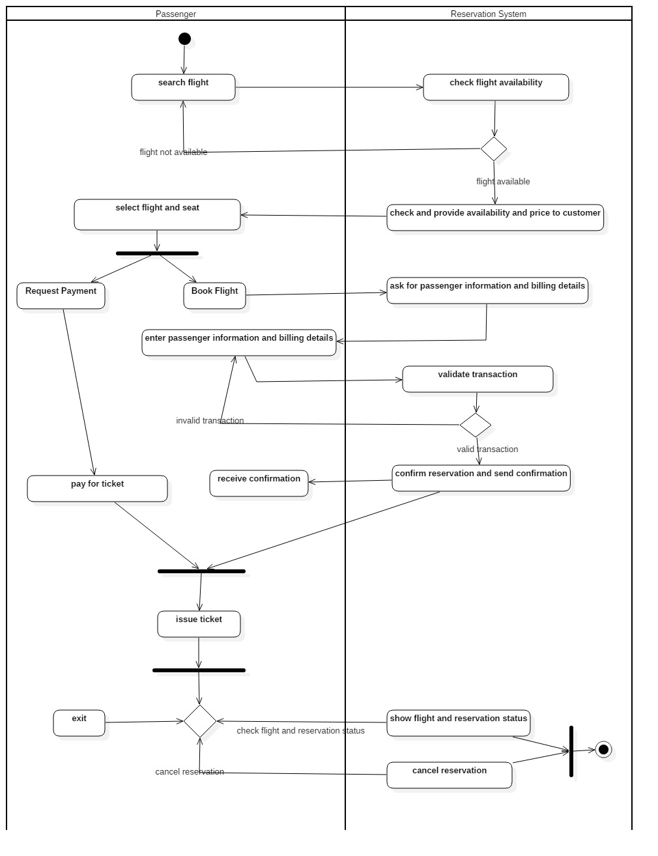

**Fig.: - Activity Diagram for online airline reservation system**

I have attached the activity diagram in my project as it is similar to other four diagrams. It captures the dynamic behaviour of the system. Other four diagrams are used to show the message flow from one object to another but activity diagram is used to show the message flow from one activity to other.

1. **SEQUENCE DIAGRAM**

A sequence diagram shows object interactions arranged in time sequence. It shows the objects and classes involved in the scenario and the sequence of messages exchanged between the objects needed to carry out the functionality of the scenario. It is a good diagram to use to document a system’s design. The reason the sequence diagram is so useful is because: -

1. It shows the interactions logic between the objects in the system in the time order that the interactions take place.
2. It shows the objects and classes involved in the scenario and the sequence of messages exchanged between the objects needed to carry out the functionality of the scenario.
3. Sequence diagram are more space efficient, simple to modify, allows vertical expansion rather that the horizontal which is the case for sequence diagram.
4. It is an essential component used in processes related to analysis, design and documentation.
5. In the context of UML, it represents object collaboration and is used to define event sequences between objects for a certain outcomes. Sequence diagram are more space efficient, simple to modify, allows vertical expansion rather that the horizontal which is the case for sequence diagram.

UML sequence diagram notation:-

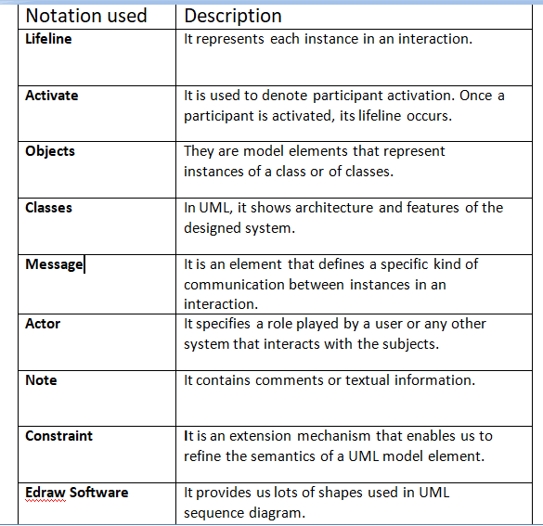

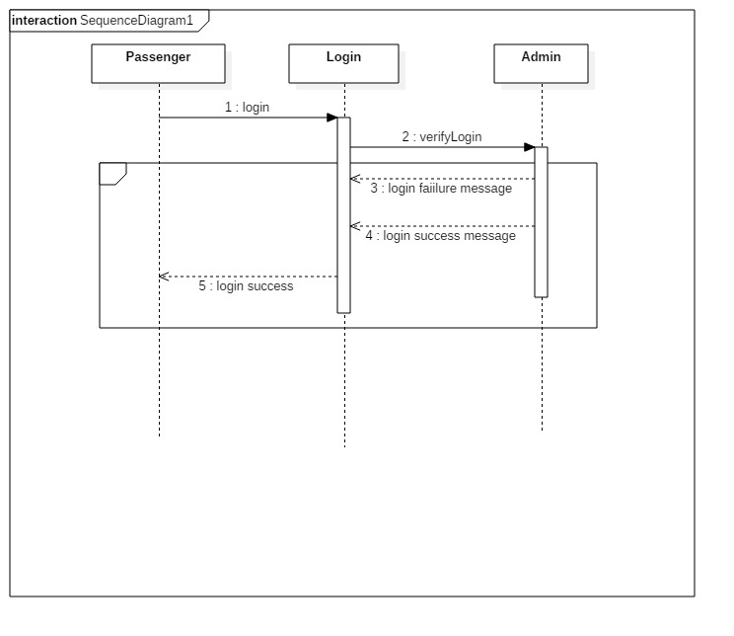

Fig.: - sequence diagram for login

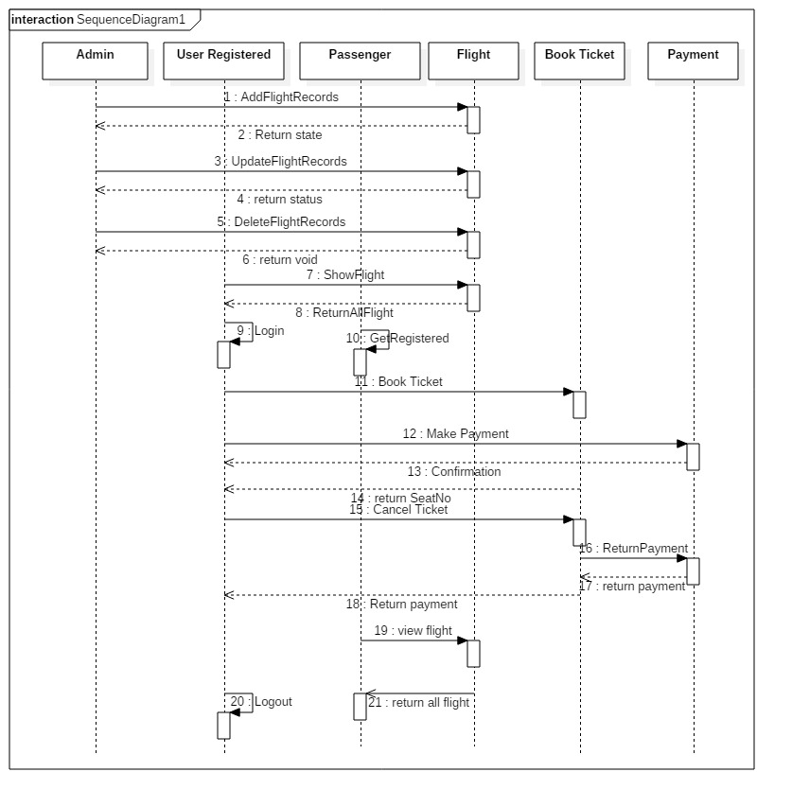

**Fig.: - sequence diagram for online airline management system**

In above project, I have mentioned the sequence diagram because it is a good diagram to use to document a system’s requirement and to smooth a system’s design. It is so useful process as it shows the cooperation logic between the objects in the system in the time order that the communications take place. These diagram are more space adequate, simple to modify, allows vertical expansion rather that the horizontal which is the case for sequence diagram. It shows the object communications managed in time sequence. They are usually linked with use case understanding in the logical view of the system.

**DATABASE**

1. **Data Dictionary**

A data dictionary is the set of sequence that describes the contents, scheme and structures of a database and the interconnection between its elements, used to control access to and management of the database.

Given below, I have included the screenshot of the summary column from my project: -

Order

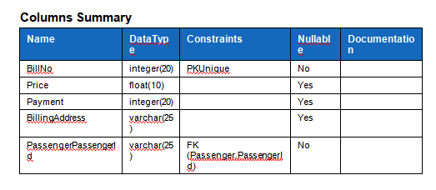

Passenger

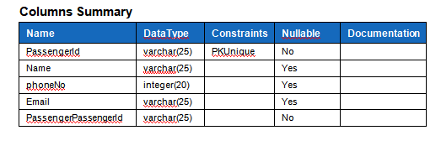

Entity

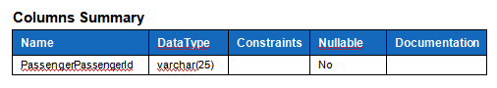

Order_travel agency

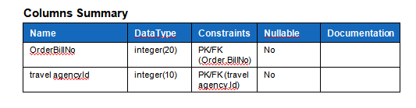

Passenger_travel agency

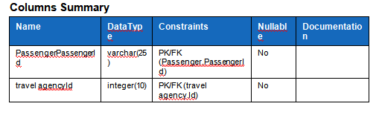

Scheduledflight

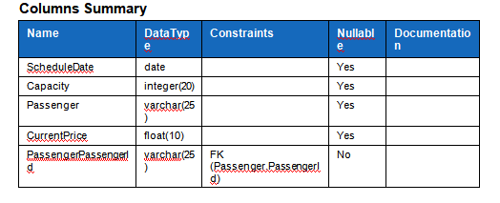

Travel agency

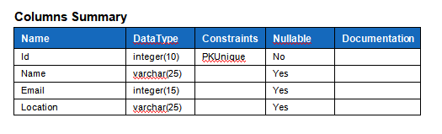

1. **ER-Diagram**

An entity relationship model describes interconnected things of interest in a specific department of knowledge. A basic ER model is combination of entity types and specifies relationship that can exist between entities. An entity can be any object, place, person or class. In ER Diagram, an entity is shown by using rectangles. I have mentioned the ER diagram for my project given below:-

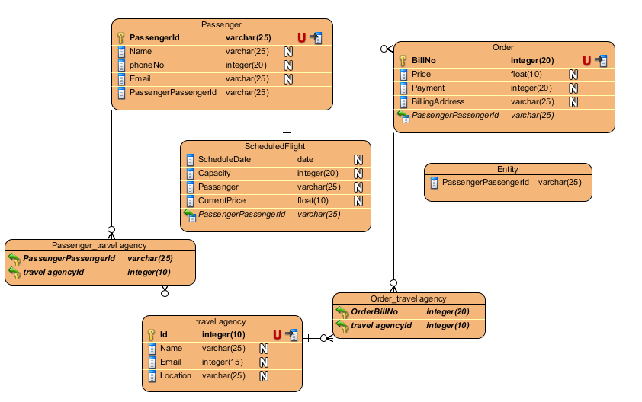

**Fig: - ER-Diagram**

**ARCHITECTURE**

System architecture is the type of architecture which determines the representation of whole layer. It is the detach model that defines the structure, behaviour and view of system.

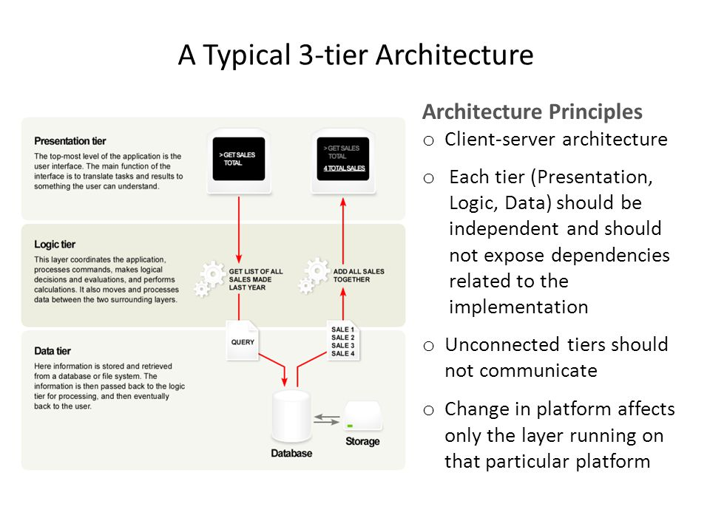

I have chosen system architecture because it helps to set up the implementation, maintenance, repair, understanding and further development of a system. The architect demonstrates a system in architecture in order to enables its usage, flexible, building and further development. It is prepared in a ways that it supports reasoning about the structures and behaviours of the system. It is made up of three tiers which provide many benefits for production and development environments by extending the user interface, business logic and storage layers. A three tier structure is a client server architecture in which the functional process, logic, data access, computer data storage and user interface are developed and maintained as self-determining modules on separate programs.

**UI**

**PROTOTYPING**

DIGITAL PROTOTYPING

A digital prototyping gives theoretical design, engineering, developing and sales and marketing departments that ability to almost explore a complete product before it’s built. Digital Prototyping is used to design, iterate, develop, validate and create their products digitally throughout the product development process. It goes ahead simply by creating product in 3D. It gives product development team a way to determine the work of moving parts. It helps to save money, time, compatibility, efficiency and more accuracy. Since, digital prototyping follows that we can get more tests in before this stage of product is dropped so it is quicker process.

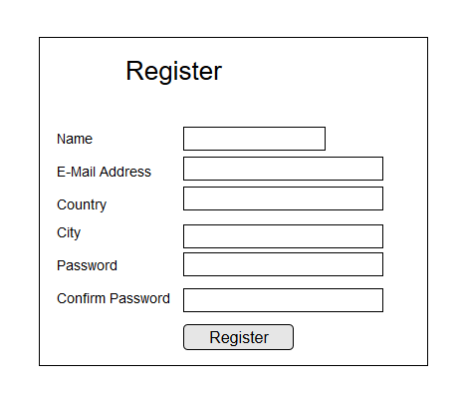

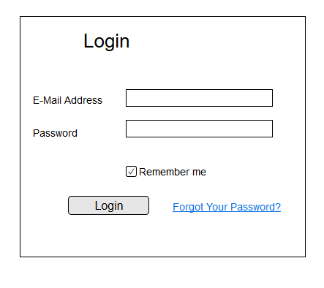

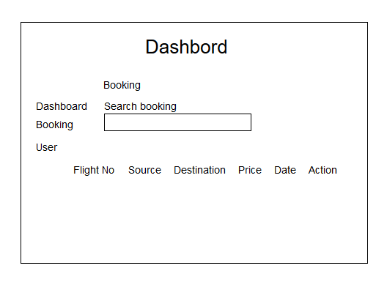

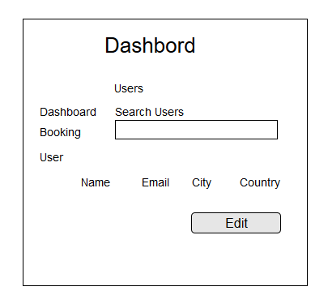

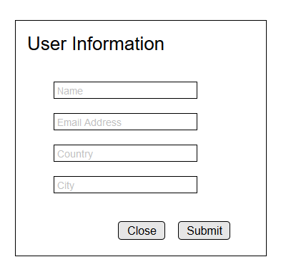

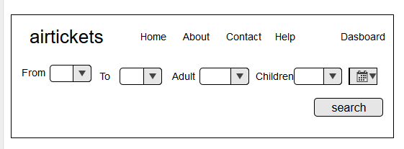

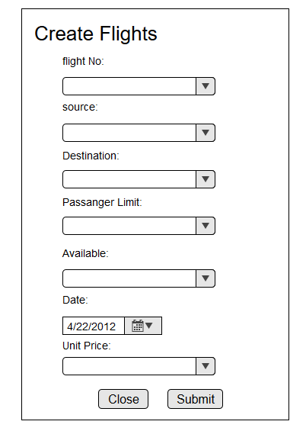

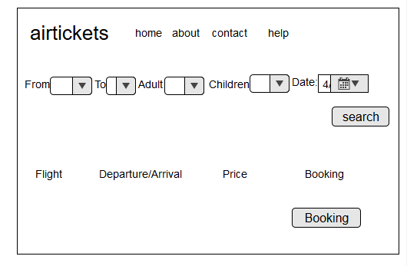

# CHAPTER-4

# CODING

Coding refers to creating computer programming code. It is the computer language which is used to develop apps, website and software. It is the set of instructions forming a computer program which is executed by a computer. It helps to solve complex problem by breaking into smaller parts. The source code is translated into machine code by a compiler or interpreter so that the computer can execute it to perform its task.

### Methodology used in coding (framework, language, tool, database)

**FRAMEWORK**

I have used laravel framework to create this project. Laravel is a PHP web framework which is created by **Taylor Otwell** and intended for the development of the web applications following model-view-controller (MVC) architectural pattern and based on symfony. Features of laravel are: -

1. It is the modular packaging system with a committed dependency manager.
2. Different ways for out breaking relatable database.
3. Utilities that help in application consumption and maintenance.

# CHAPTER-5

# TESTING

Testing is one of the important phase of making website or any other application without which we can’t say our system is whether user friendly or not. So, we cannot say that our system is doing great job without performing testing.

Testing is the process of finding out something like website application’s capacities and performance etc. It helps to find out what rank of data or capacity has been carried up. In PC hardware and programming change, testing is done to check whether the particular targets are being met or not. It is used to estimate the functionality of a software application with an aim to find whether the developed software met the particular requirements or not. It also helps to identify the flaws to protect that the product is flaws free in order to produce the quality product.

## Types of testing

There are different types of testing which is mention below:

1. Unit Testing
2. System Testing
3. Acceptance testing
4. Integration Testing
5. Functional Testing
6. Alfa Testing
7. Usability Testing
8. Black box Testing
9. White box Testing
10. Beta Testing

Among them, I have chosen unit testing and black box testing for my project.

**Unit Testing**

Unit testing is the type of software testing where individual unit of software is tested. This testing is done during the coding development of the project. The main objective of unit testing is to isolate a section of code and verify its correctness. It is the smallest part of individual unit which find out if they are fit for use. Unit testing helps to find out software bugs earlier, provides quality of code and documentation, facilitates change and simplifies integration.

**Black Box Testing**

Black box testing which is also known as the behavioural testing is a method of software testing that identifies the functionality of an application without observing closely into its internal structures and workings. This method of test can be applied nearly to an every level of software testing. Testing either functional or non functional without suggestion to the internal structure of the component or system.

# Chapter 6: Other Project Issues

## 6.1 Risk Management

Risk management is the calculation and prioritization of risk in time and cost-effective application of resources to reduce, examine and manage the certainty or impact of adverse events. This management helps to increase the understanding of opportunities also risk management is done in order to identify their risk and to minimize their impact also. Software Development uses different technological advancements and that development has some uncertainly which is called as Risk.

To make any project success, the first and foremost thing is it must be bug or error and risk free. Risk must be identified to make any software development success. It is the obstacle for any project. There will be a loss of time, effort and money if the risk is not identified before completion of any project. The succession of any project will be compromised if the risk is not identified in the early stage.

In software development, Risk Management is done in order to identify, manage, monitor and control the probability or impact of unfortunate events by identifying, analysing and prioritizing the risk. Risk identification, analysis and risk control are the three types of risk which is define below: -

1. Risk identification

This is the initial steps of risk management where we need to identify risk, their impacts and describe potential risk that might affect our project during software development.

1. Risk Analysis

After identifying the risk, we need to analyze nature of the risk, it possibility and consequences and its potential to concern project goals and objectives.

1. Risk Control

For succession of any project, risk must be analyzed, managed, control, monitor and remove and assess the risk impact.

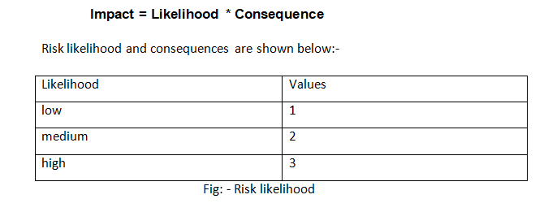

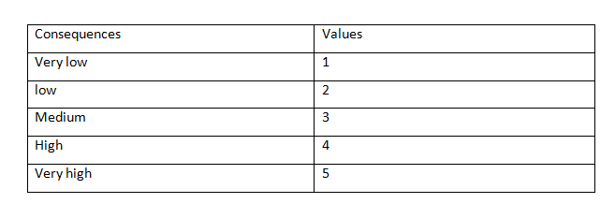

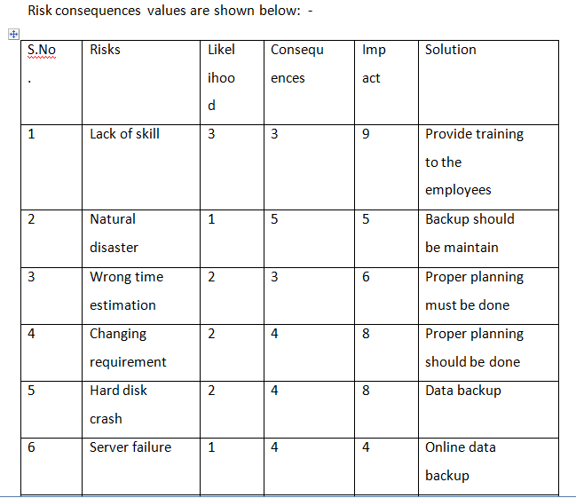

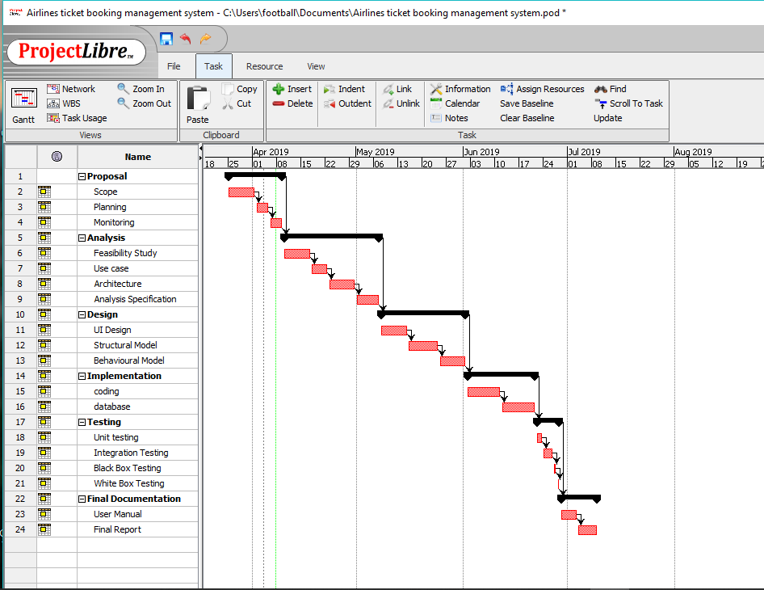

## 6.2 Configuration Management

The term refers to the process which is done for organizing and maintaining stability of a product’s presentation, functional and objective attributes with its needs, structure and effective information. Configuration management provides control and improves visibility. It also diminishes the cost by providing detailed information of the system which allows for needless repetition to be avoided.

### 6.2.1Version Control

It is the software tool which helps to manage and control source code of developer. It is the backbone for any project. One can easily view source code and their modification date also.

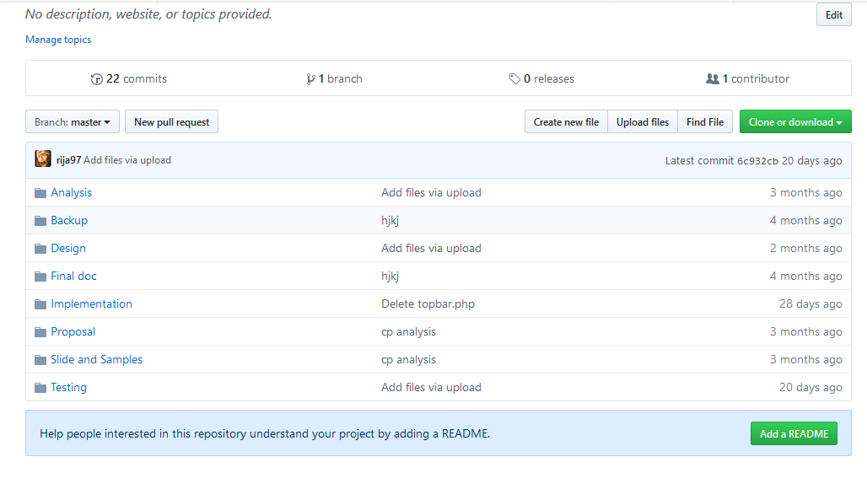

Figure 49: GitHub for Air Ticketing

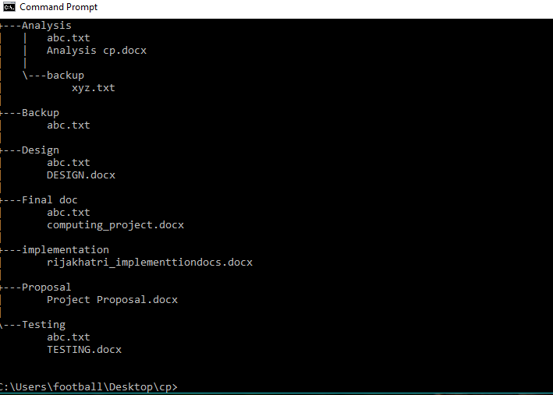

Figure 50: Tree structure

## 6.3 PROJECT ISSUES

First of all, I have created the prototype of my project. Prototype is the design of my whole project which shows what type of function is going to perform. It helps to complete the task by making ease. After completing the prototype, I started to implement by doing source code which is important part. Without source code we cannot perform any project. The main aim of my project is to be user friendly and easy to use. A lot of problems arise during the completion of my task but with the help of tutorial, friends and seniors, I have solved that problem. Project issues are actions that have occur and affected the quality, cost and time estimation of the project. They can be recoverable also and differ from risk. Issue is either a risk that could be less severe.

An issue record is a simple list or database that helps managers to track the problems that arise in a project and estimate a response to them. Issues are different than a risk which is defined as a future issue that might happen in our project. Numerous issues arise during the completion of my project and by the help of others I have completed my task successfully. Now my project is user friendly and easy to use.

## 6.4 LIMITATION

The limitation of my project is given below:-

* User can check the price for flight but online payment is not available.
* User can only cancel their tickets; they are not allowed to update tickets.
* Online booking of hotel and transportation is not available.
* User cannot book their ticket offline.
* User cannot book seat as per their choice.

## 6.5 FUTURE WORK

As my project is an academic so I have provided with limited time to complete my project. There any many features which I want to include in my project but due to time boundary and lack of knowledge, I was unable to include those features which I had told in proposal. Therefore, I will surely include those features in my future update: -

* Online payment system
* Flights rating and reviewing
* Security features and secure information handling for user
* Seat choosing
* Allowing user to observe available seats
* User can pay with cards
* Providing offers and discounts

## 6.6 USER MANUAL

As clients are new for the system, so they don’t know how to register, book their ticket and perform other functions also. To teach them how to cooperate with the system, I have created a user manual for teaching them working mechanism to operate new system.

* New user

New users are new for the system. They don’t know how to tackle with the operating system. They cannot book ticket without registering their personal details. So here unregister user can register their details inserting their required personal details.

Steps for registration: -

* Click on the register button which is on the top right side of navbar.
* After that, registration page will open, fill your details in textbox and click on register button.

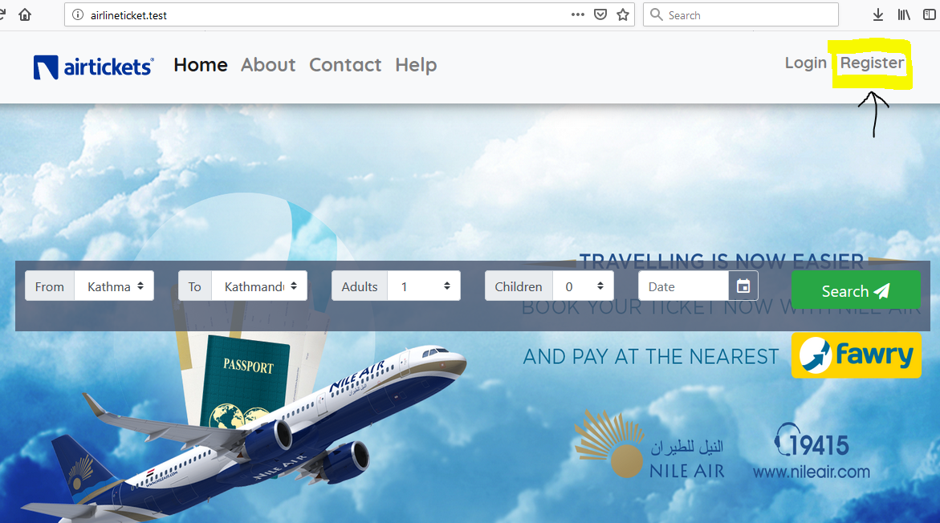

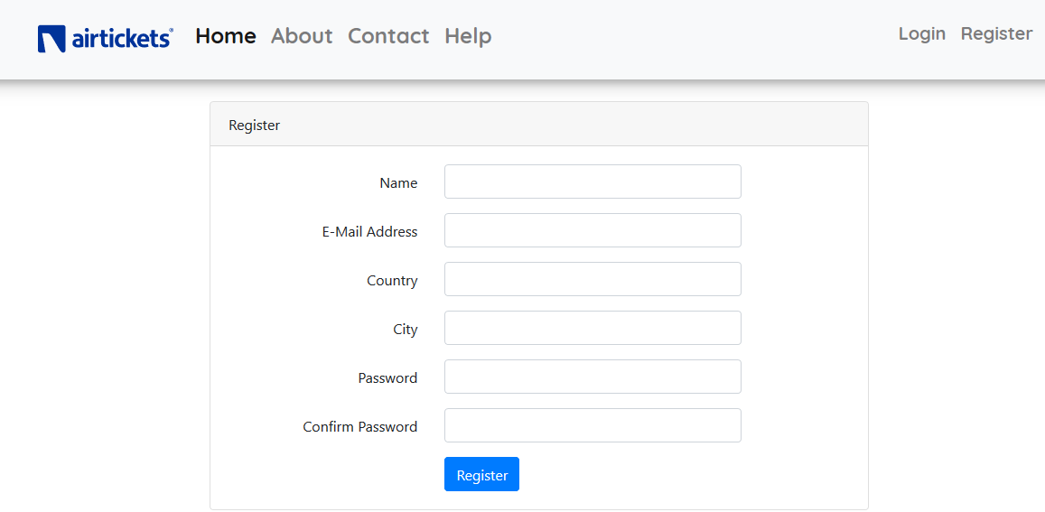

* Register user

Register user can view and update their personal details, book and cancel ticket, view flights.

Steps for registration user: -

* User should login their detail by clicking on the login button on the top right side.
* After that login page will open where they need to insert their email and password and click on the login button.

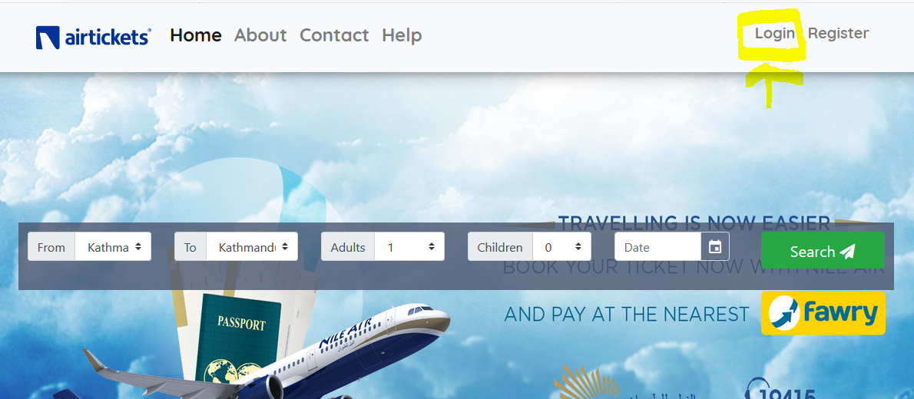

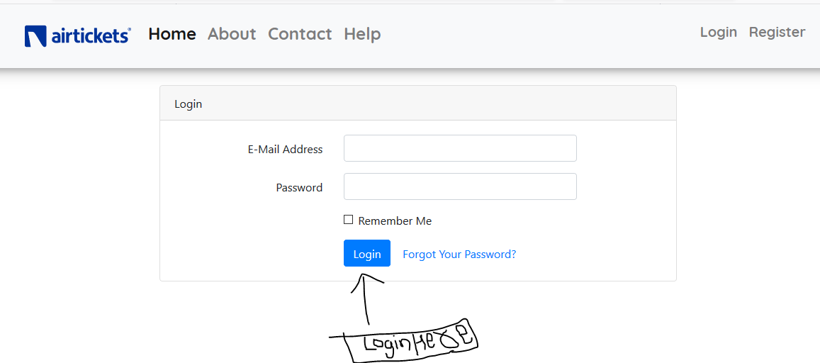

* Click on the edit button to update your personal details.

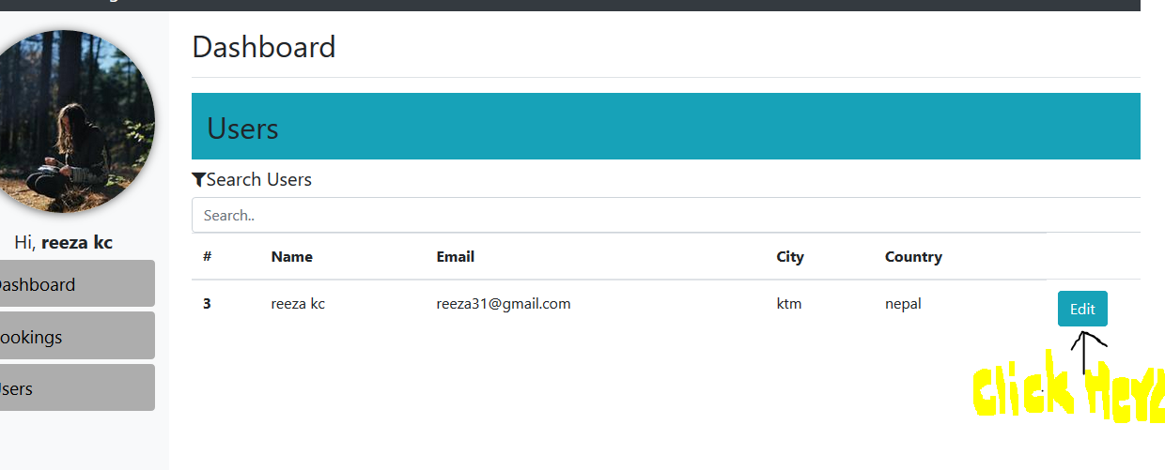

* After updating your personal details, click on the submit button.

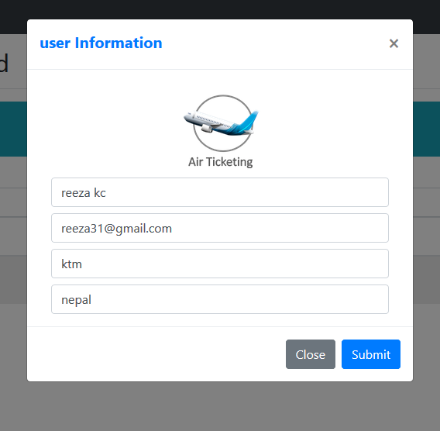

* Search for flight by entering your destination and click on the search button.

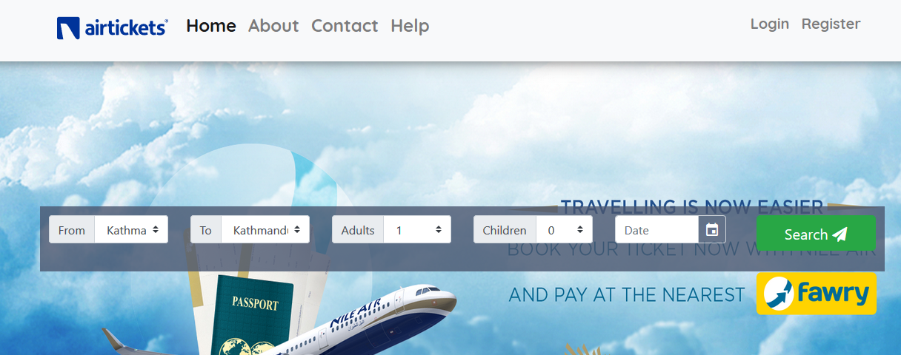

* If your flight is available, book it by clicking on the book button.

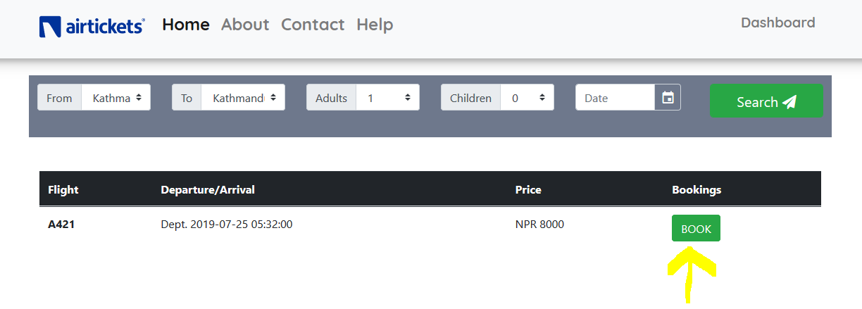

* If you want to cancel your booking, click on the cancel button.

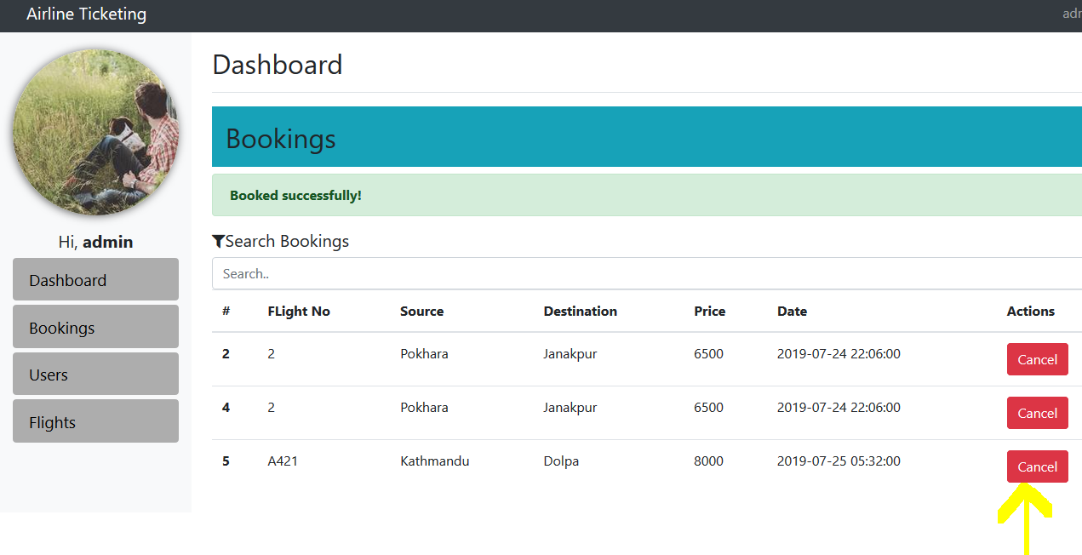

* If user wants to logout then click on the logout button on the top right side.

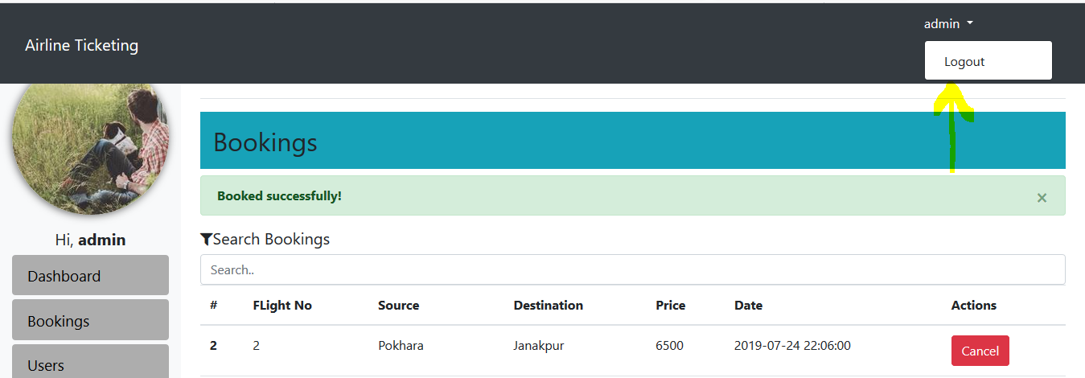

# CHAPTER-7

## APPENDIX

Screenshot of implementation of Laravel design in MVC pattern: -

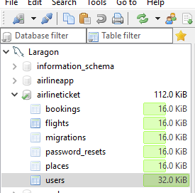

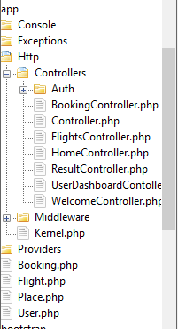

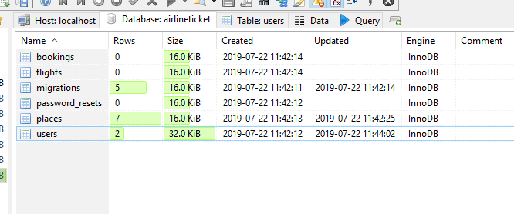

Controller

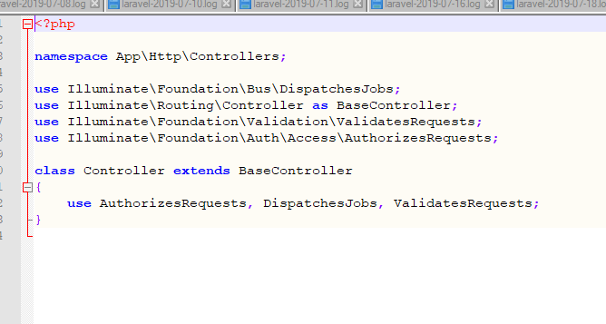

1. Booking controller

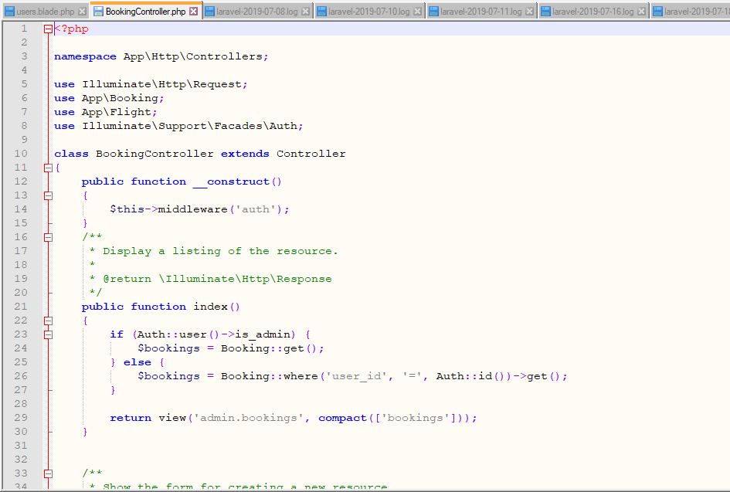

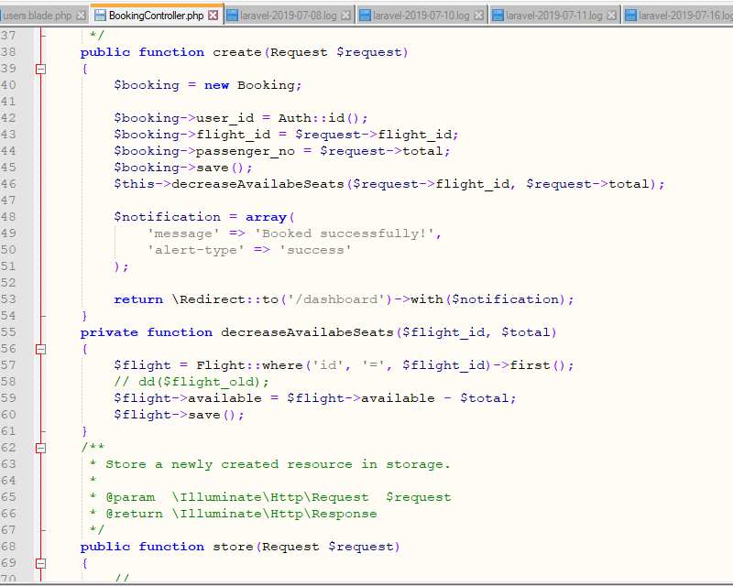

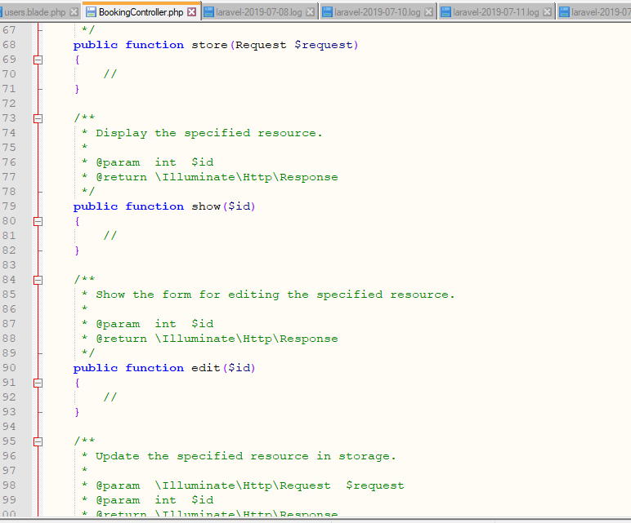

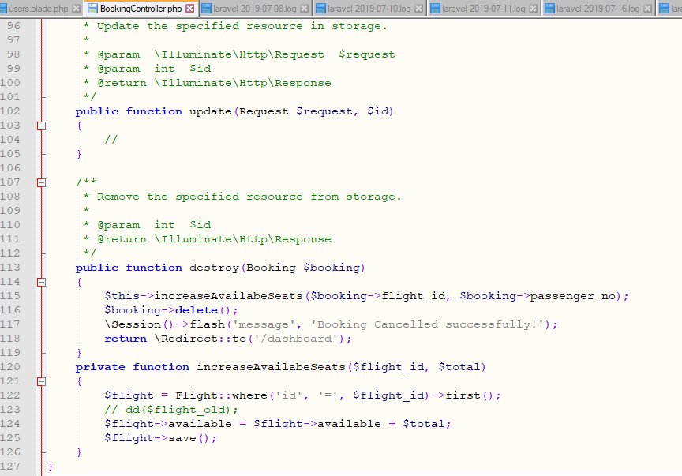

1. Flight controller

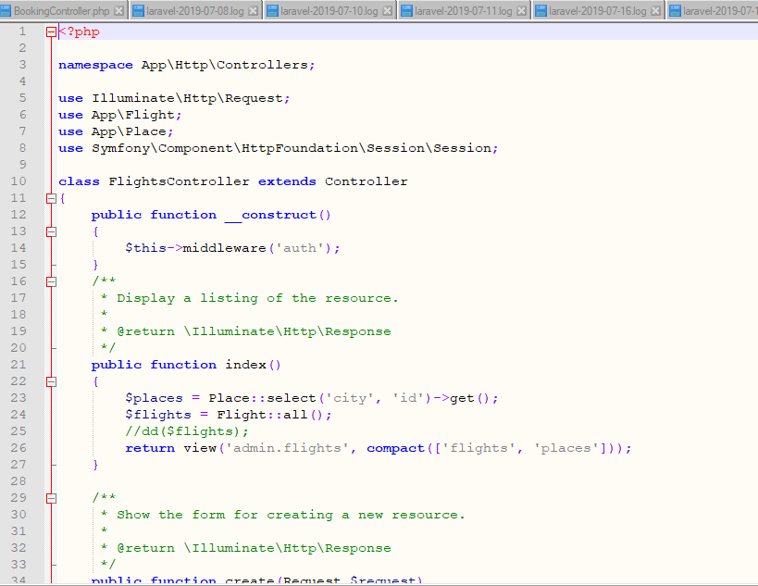

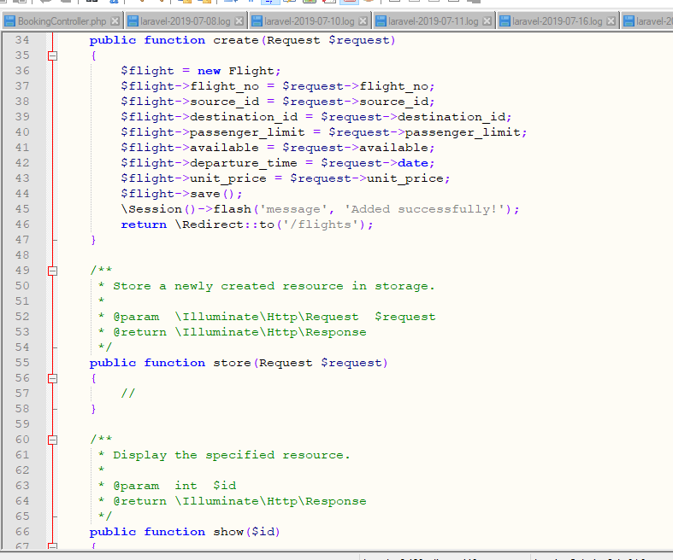

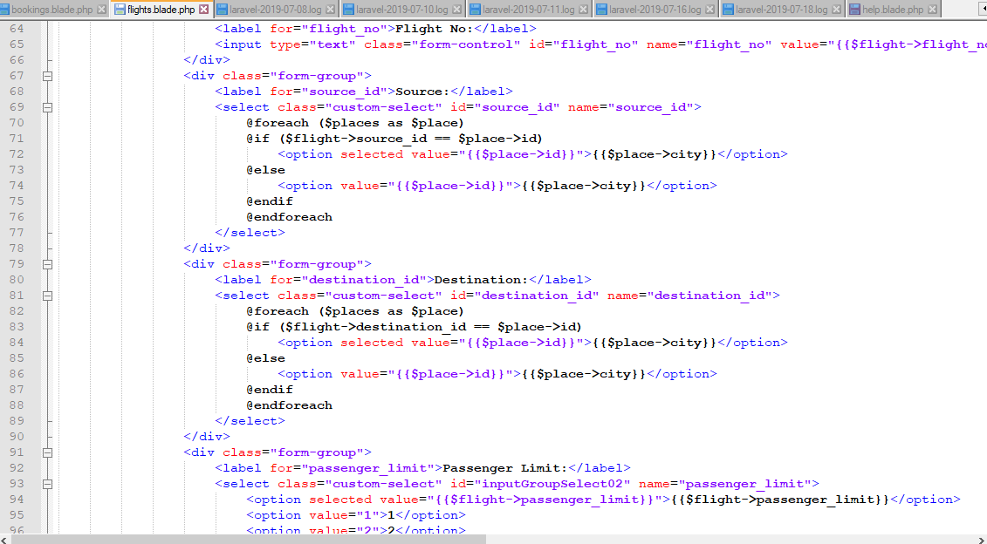

1. Home controller

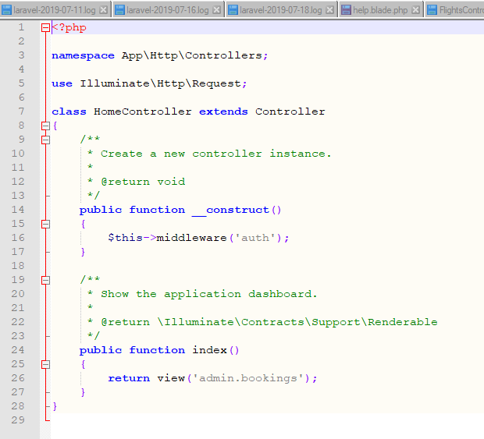

1. User Dashboard controller

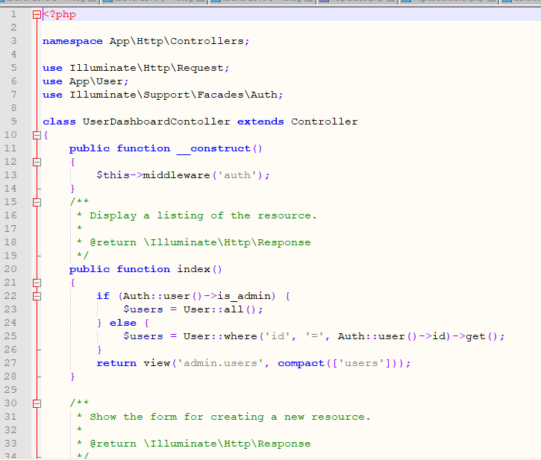

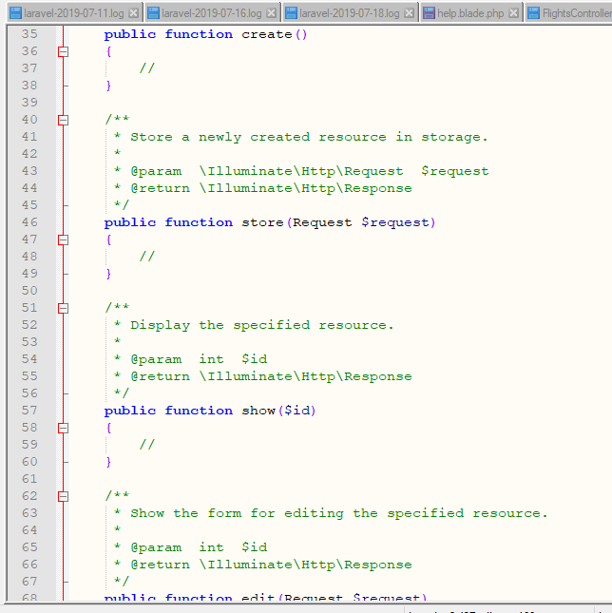

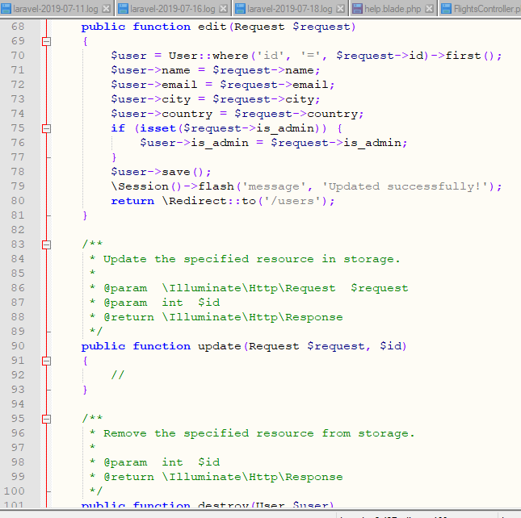

# CHAPTER-8

## CONCLUSION

Online airline ticket booking system is a type of system which is created to provide direct services to the customer or passenger. It is a customized and user friendly web application where user can easily search for flight, book ticket and cancel also. Admin can update, add and delete flights.

In my project, I have used PHP with Laravel framework and MVC design pattern and done different types of analysis also. As my project is user friendly, user can book their tickets without visiting ticket counters, standing in a long queue or contacting with any travel agents. The main aim of my project is to provide more ease to the users while booking tickets as much as I can. I have done testing also in order to be sure whether my project is bugs free or not. The main limitation in my project is there no online payment facility so I have included this in my future work. There are many other future plans and limitations in my project. I have discussed types of risk and configuration management in my project also. Finally, my project is completed which is customize and user-friendly.